2024

Handbook and racing programme
Invergordon Boating Club
Established 1901
INVERGORDON BOATING CLUB
ROSSKEEN SLIPWAY INVERGORDON

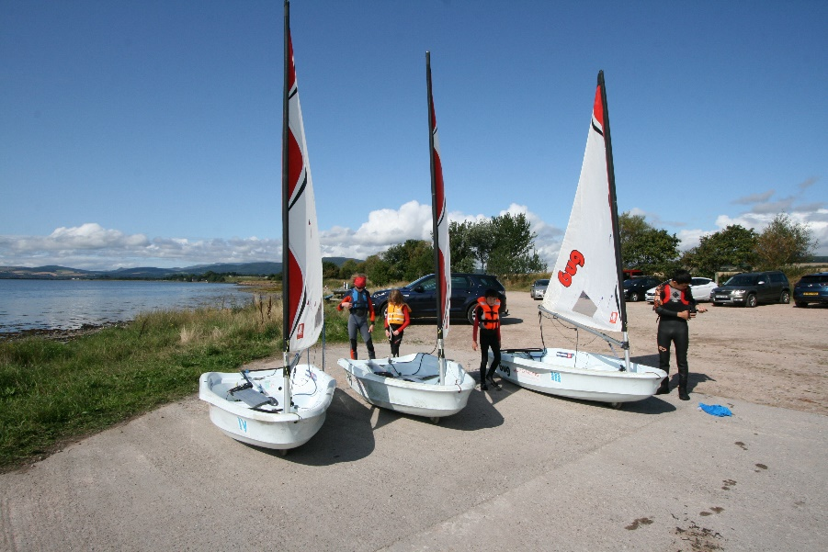
Office Bearers
Commodore Inga Ovenstone
Vice Commodore Ian Thorburn
Secretary Andrew Pennington
Rear Commodore Robert Dineen
Treasurer Matt Dent
Membership Secretary Phil Tomalin
Training Principal Martin Crawshaw
Bosun Robin Woodford
Committee members Fred Fraser, John Edmondson, Tom Owen, Andy Walters

SAFETY AFLOAT
RISK STATEMENT [Courtesy of RYA]
Rule 4 of the Racing Rules of Sailing states: "The responsibility for a boat's decision to participate in a race or to continue racing is hers alone."

Sailing is by its nature an unpredictable sport and therefore inherently involves an element of risk. By taking part in the event, each competitor agrees and acknowledges that:
(a) They are aware of the inherent element of risk involved in the sport and accept responsibility for the exposure of themselves, their crew and their boat to such inherent risk whilst taking part in the event;
(b) They are responsible for the safety of themselves, their crew, their boat and their other property whether afloat or ashore;
(c) They accept responsibility for any injury, damage or loss to the extent caused by their own actions or omissions;
(d) Their boat is in good order, equipped to sail in the event and they are fit to participate;
(e) The provision of a race management team, patrol boats and other officials and volunteers by the event organiser does not relieve them of their own responsibilities;
(f) The provision of patrol boat cover is limited to such assistance, particularly in extreme weather conditions, as can be practically provided in the circumstances;
(g) It is their responsibility to familiarise themselves with any risks specific to this venue or this event drawn to their attention in any rules and information produced for the venue or event and to attend any safety briefing held for the event;
(h) [For offshore races] They are responsible for ensuring that their boat is equipped and seaworthy so as to be able to face extremes of weather; that there is a crew sufficient in number, experience and fitness to withstand such weather; and that the safety equipment is properly maintained, stowed and in date and is familiar to the crew]; and
(i) [If not covered elsewhere in the Notice of Race] their boat is adequately insured, with cover of at least [£2 million] against third party claims].
Please see the club website for our full risk assessment and Health & Safety policy.
Mandatory IBC rules for competitors
All skippers must fill in the race entry sheet
All boats entered must have a name, preferably clearly marked on the hull and a sail number
ALL SAFETY BOAT CREWS AND PARICIPANTS IN SAILING EVENTS MUST WEAR
PERSONAL BOUYANCY
IBC will not accept any liability for material damage to boats, personal injury or death
to participants sustained before, during or after an event.

FREE SAILING
Club Members are entitled to sail from the club at any time they wish outside of organised club activities.
However, they must take full responsibility for the safety of themselves and crew while they are on the water.
GENERAL INFORMATION
Clubhouse
House rules are displayed on the notice board downstairs. Members are requested to acquaint themselves with them and to ensure that the premises are kept in a clean and tidy condition. Specifically, wet sailing clothing should not be worn upstairs in the clubhouse.
All members must ensure that the lights and heaters are switched off before leaving the club house. The water supply should be shut off and drained during winter.
Security
Security is of paramount importance so please ensure that the clubhouse, boatshed and compound are locked after use. The compound is secured by a combination padlock. You should have been given the number when you joined the club but if you didn’t receive it please contact any committee member. Clubhouse keys are available from the Treasurer for a £5 refundable deposit should you wish one. Inflatables & outboards may be stored in the shed, but at the owner’s risk, and not impeding the use of the boatshed by other members.
The compound and Club must not be left open while members visit their boats at moorings if no members are present ashore.
The Slipway
The slipway is for public use and is not owned or maintained by IBC. Launching trolleys & trailers should not be left in a manner which impedes or restricts access to other users.

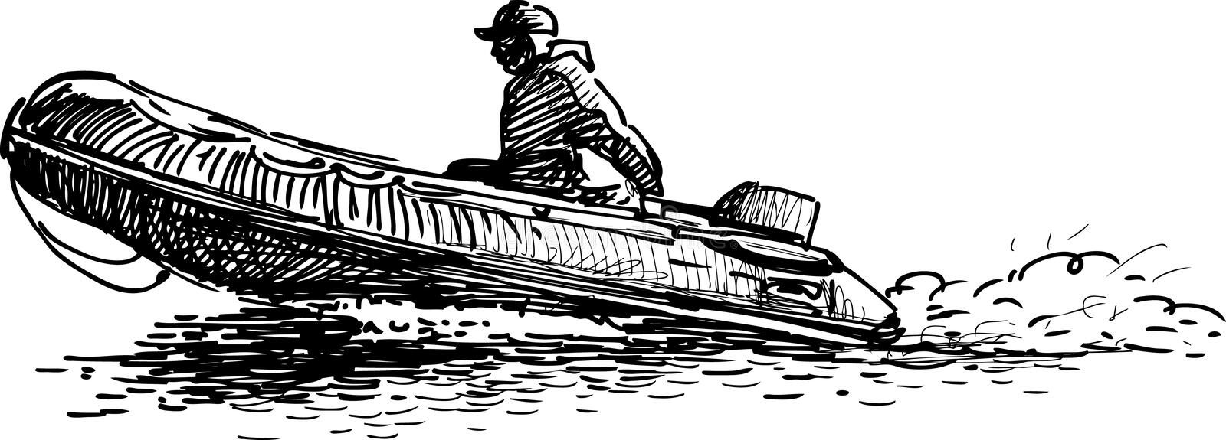
Swinging Moorings
Members intending to lay moorings should ensure that the ground tackle and other components are of adequate strength for the intended vessel and the exposed nature of the anchorage. A copy of the club mooring guide is available from the moorings master, or from the web site, but the design is the sole responsibility of the owner.
GENERAL INFORMATION

Club Sailing Dinghies
The club owns several dinghies, which are primarily intended for sail training and tuition. Members can however use these boats for other activities subject approval by a member of the management committee.

Safety Boats
Rules regulating the use of the club boats are available in the race office.
Persons operating these vessels must comply with the rules and hold an appropriate RYA powerboat certificate or be of suitable experience.
Please ensure that CFPA is contacted if using a safety boat within the harbour area. (On VHF Channel 11 – call sign “Port Radio”)

OOD Duties
The person or boat crew named for the above duties must accept full responsibility for providing that service whether carried out personally or deputized to a qualified replacement. Wherever possible, a team of 2 should be allocated for OOD. Dinghy crews must also provide a competent crew for Safety Boat duties and ensure the boat is suitably fueled, equipped and ready for use.

- The rota for the OOD and Safety boat duties will be this Booklet and posted on the clubhouse notice board.
- No dinghy racing is permitted unless a suitably crewed, fueled and equipped safety boat is in attendance.
- VHF Radio check should be carried out before any rescue boat crew goes on the water.
- Dinghy racing should be abandoned if weather conditions are unsuitable or deteriorate during a race. Three blasts on the starting horn indicate abandonment.
- If a crisis arises beyond your control, do not delay in calling the emergency services – Dial 999 and ask for the coastguard.
A 24 hour radio watch is maintained on VHF Channel 11, Call - sign “port radio”. Local weather forecasts are broadcast daily at 0815/1730 and will be reported on request.

SAILING INSTRUCTIONS
Rules
Racing will take place under the Racing Rules of Sailing 2021-2024, RYA prescriptions and class rules, supplemented by these sailing instructions.

Conditions of entry
The safety of a yacht /dinghy and her entire management including third party insurance shall be the sole and inescapable responsibility of the owner or skipper. All skippers, and regular crews, competing in club events must be members of IBC.

All boats most have at least £2,000,000 third party insurance.

Handicaps
Skippers of Boats equipped with spinnakers, when entering series events, must declare at the outset their intentions to claim the handicap allowance for white sails only racing and complete all races in that series without spinnakers.

Course instructions
The OOD will communicate the course to be sailed either from the standard course card listed in this handbook or a course made up by the OOD to give the best racing for the wind direction. The course will be indicated on a board hung from the clubhouse veranda or on a notice in the clubhouse and communicated to skippers at sign on.
Courses shall only be shortened to finish the race at a lap completion at Mark 1 or A.

Starting procedures
In accordance with the Racing Rules of Sailing 2021 – 2024 Rule 26

Recalls
Will be in accordance with the Racing Rules of Sailing 2021-2024 Rule 29

SAILING INSTRUCTIONS Continued
Starting Penalties
Will be in accordance with the Racing Rules of Sailing Rule 30

Start/ finish line
Shall be defined by an imaginary line projected from the flagpole on the Clubhouse veranda to
Race Mark 1 for keelboats and Race Mark A for dinghies.
Race Mark 1 may also be used for starting dinghies when there is insufficient water depth at Race Mark A and when indicated on a board at sign on

Taking a Penalty
A boat may take a Two-Turns Penalty when she may have broken one or more rules of Part 2 in an incident while racing. She may take a One-Turn Penalty when she may have broken rule 31.

Time Limits
Time limits will govern all racing. (See midweek start times) If no yacht finishes within the time limit, the race is null and void. If 1 or more yachts finish within the time limit, all other competing yachts must finish within 30 minutes of the time limit or retire.

Protests
Protests must be lodged with the OOD in writing in accordance with World Sailing – RRofS rule 61 within 1 hour of publication of the results.

Entering a Club Race
It is essential that all race skippers or deputies formally enter each race by ‘signing on’ in the entry book in the starter’s box, before the race commences. Information entered must include boat name and handicap.

Declaration
On completion of every race, the skipper of each vessel or his/her nominee must sign the race entry sheet to confirm compliance with the rules. The OOD is permitted some discretion in implementing the rule.

Midweek start times – Start time for all races will be7.00PM. Dinghy time limit is 1.5 hours. Keel boat time limit is 2 hours. The time limits are minimums and may be increased at the race officer’s discretion.

Scoring
Shall be as the Racing Rules of Sailing Appendix A (variations below).
The Club Championship is scored by adding the place for each qualifying event, not each individual race. DNC in a qualifying Series/Event for the Championship is scored as the highest number of boats in a qualifying Series/Event for that Season + 1.
Average points from all races (excepting the duty race) are awarded for doing the safety boat or OOD when regularly sailing in that Series.
Dinghy Results --- Results for Dinghy races will normally be calculated using average lap times

Invergordon Boating Club – Events 2024
Day |  | Event | Time | OOD | Safety | HT. DST
March
Sun | 24 | Spring Meeting | 1200
April
Fri | 5 | Keel Boat Crane In |  | F Fraser
Sun | 7 | Work party | 1000
Sun | 14 | Opening Event – dinghy shake down | 1100 | A Pennington | I Thorburn | 1713
Tues | 16 | Dinghies – Spring Race 1 | 1900 | F Fraser | M Dent | 1918
Wed | 17 | Keel Boat – Spring Race 1 | 1900 | J Edmonson |  | 2042
Tues | 23 | Dinghies – Spring Race 2 | 1900 | I Ovenstone | A Gunn | 1248
Wed | 24 | Keel Boat – Spring Race 2 | 1900 | P Burnell |  | 1322
Tues | 30 | Dinghy – Spring Race 3 | 1900 | F Munro | T Owen | 1723
May
Wed | 1 | Keel Boat – Spring Race 3 | 1900 | N Cormack |  | 1832
Tues | 7 | Dinghies – Spring Race 4 | 1900 | P Tomalin |  | 1212
Wed | 8 | Keel Boat – Spring Race 4 | 1900 | S Dolan |  | 1303
Sat | 11 | Safety boat training | 1000 | M Crawshaw |  | 1520
Sun | 12 | Open day | 1030 | M Crawshaw, I Ovenstone | I Thorburn | 1608
Tues | 14 | Dinghies – Spring Race 5 | 1900 | P Whiles | A Pennington | 1751
Wed | 15 | Keel Boat – Spring Race 5 | 1900 | A Walters |  | 1848
Tues | 21 | Dinghies – Spring Race 6 | 1900 | T Owen | S Hewett | 1130
Wed | 22 | Keel Boat – Spring Race 6 | 1900 | R Nelson |  | 1214
Sun | 26 | Dinghy level 1 course | 1100 | M Crawshaw | F Fraser | 1452
Tues | 28 | Dinghies – Spring Race 7 | 1900 | K Laird | P Burnell | 1627
Wed | 29 | Keel Boat – Spring Race 7 | 1900 | M Dent |  | 1722
June
Sun | 2 | IBC Dinghy Regatta | 1100 | I Ovenstone | I Thorburn | 0834
Tues | 4 | Dinghies – Summer Race 1&2 | 1900 | A Gunn | F Munro | 2345
Wed | 5 | Keel Boat – Summer Race 1 | 1900 | A Pennington |  | 1153
Sat | 8 | Whitehills to Kirkwall Race
Tues | 11 | Improvers | 1900 | A Walters | J Edmonson | 1639
Wed | 12 | Keel Boat – Summer Race 2 | 1900 | I Ovenstone |  | 1724
Tues | 18 | Dinghies – Summer Race 3&4 | 1900 | P Tomalin | R Nelson with R Dineen | 2235
Wed | 19 | Keel Boat – Summer Race 3 | 1900 | S Hewett |  | 2323
Sat | 22 | North Kessock Race
Tues | 25 | Improvers | 1900 | M Dent | T Owen | 1535
Wed | 26 | Keel Boat – Summer Race 4 | 1900 | V Spreadborough |  | 1624
Sun | 30 | Sunday Splash About | 1100 | A Walters | A Pennington
JULY
Tues | 2 | Dinghies. Summer Race 5&6 | 1900 | K Laird | F Fraser | 2221
Wed | 3 | Keel Boat – Summer Race 5 | 1900 | P Burnell |  | 2321
Tues | 9 | Improvers | 1900 | A Pennington | P Burnell | 1533
Wed | 10 | Keel Boat – Summer Race 6 | 1900 | R Nelson |  | 1611
Tues | 16 | Dinghies Summer Race 7&8 | 1900 | I Thorburn | I Ovenstone | 2051
Wed | 17 | Keel Boat – Summer Race 7 | 1900 | P Whiles |  | 2150
Tues | 23 | Dinghies – Autumn Race 1 | 1900 | A Gunn | S Hewett | 1438
Wed | 24 | Keel Boat – Autumn Race 1 | 1900 | R Woodford |  | 1524
Sun | 28 | Nigg Cup | 1000 | I Ovenstone | L Whittenham  I Ovenstone | LW1207
Tues | 30 | Dinghies – Autumn Race 2 | 1900 | F Fraser | A Walters | 2033
Wed | 31 | Keel Boat – Autumn Race 2 | 1900 | S Dolan |  | 2153
August
Sat | 3 | Storehouse race/cruise | 1000 | T Owen | N Reid | 1237
Tues | 6 | Dinghies – Autumn Race 3 | 1900 | I Ovenstone | R Dineen | 1432
Wed | 7 | Keel Boat – Autumn Race 3 | 1900 | N Cormack |  | 1504
Sat | 10 | IBC Keel Boat Regatta | 1100 | J Burgis |  | 1625
Tues | 13 | Dinghies – Autumn Race 4 | 1900 | P Tomalin | J Edmonson | 1824
Wed | 14 | Keel Boat – Autumn Race 4 | 1900 | L Gunn |  | 1940
Sat | 17 | MFCR @ Cromarty | 1100 | J Burgis |  | 1057
Tues | 20 | Dinghies – Autumn Race 5 | 1900 | P Whiles | I Ovenstone | 1336
Wed | 21 | Keel Boat – Autumn Race 5 | 1900 | I Ovenstone |  | 1420
Tues | 27 | Dinghies – Autumn Race 6 | 1900 | I Thorburn | M Crawshaw | 1850
Wed | 28 | Keel Boat – Autumn Race 6 | 1900 | S Hewett |  | 2003
September
Sun | 1 | Sunday Splash About | 1100 | A Walters | I Ovenstone | 1228
Tues | 3 | Dinghies – Autumn Race 7 | 1900 | P Burnell | M Dent | 1335
Wed | 4 | Keel Boat – Autumn Race 7 | 1900 | K Laird |  | 1403
Sat | 7 | CBC Keel Boat Regatta |  |  |  | 1517
Sun | 15 | Bart's Bash | 1100 | I Ovenstone | T Owen | 1041
Sat | 21 | Black Isle Challenge Cup @ CSC | 1200 |  |  | 1517
Fri | TBC | Keel Boat Crane Out |  | F Fraser
November
Fri | 1 | IBC Dinner & Prize Giving

DINGHY COURSE CARD
The courses listed below are suggestions for guidance, the OOD is encouraged to select or make up a course that will give the best racing for the wind direction.
The number of laps should not be set, the race should continue until the OOD stops racing by displaying flag board “S”. Boats will then finish when they next pass the Start/Finish mark.
Courses starting westward
1 Ap 2p 8p Ap
2 Ap Bp 8p Ap
3 Ap 2p 1p Ap
4 Ap Bp 1p Ap
5 Ap 2p Xp Ap
6 Ap Bp Xp Ap
7 Ap 2p 5p 8p Ap 2p 8p Ap
8 Ap Bp 5p 8p Ap Bp 8p Ap
9 Ap then windward/leeward using 2p 8p
10 Ap then windward/leeward using Bp 8p
Course starting eastward
11 As 8s 2s As
12 As Bs 2s As
13 As 8s 1s As
14 As Bs 1s As
15 As 7s Xs As
16 As Bs Xs As
17 As 8s 5s 2s As 8s 2s As
18 As Bs 5s 2s As Bs 2s As
19 As then windward/leeward using 8s – 2s
20 As then windward/leeward using Bs – 2s
Mark A will be the Orange Buoy Marked A
Marks B and C will be drop buoys which, if required, will be positioned by the rescue boat, before the race starts, to allow best courses to be set.

KEELBOAT COURSE CARD
Courses Starting Westward
1. 1p Yp Xp 1s 8s 5s Ys 1s Xp 8p 1p
2. 1p 2p 5p 7p 1p Xp 8p 1p 2p 5p 7p 1p Xp 8p 1p
3. 1p Yp 5p 2p 4p 8p 1p Yp 5p 2p 4p 8p 1p
4. 1p 4p 6p 7p 1p 5s 4s Ys 1s
5. 1p 2p Xs 5p 7p Xs 1p 2p 5p 7p Xs 1p
6. 1p 4s 2p Yp Xp 1s 8p 1p 4s 2p Yp Xp 1s 8p 1p
A. 1p 2p 6p Nigg East s, Buss Bank s, Newhall s, 1p
B. 1p 4p 6p Nigg East p, Nigg West p, Xs 1p
C. 1p Yp 5p 7s Newhall p, Nigg West p, 6s 1p
D. Light Wind from West, 1p 2p 1s 8s 1p 2p 1s
Course Starting Eastward
7. 1s 8s 5p 6p 7p 1s 8s 5p 6p 7p 1p
8. 1s 7s 5s 2s Xp 8p 1p 7s 5s 2s Xp 8p 1p
9. 1s 6s 5s 8p 2s 1s 6s 5s 8p 2s 1s
10. 1s 7s 4p 5p 2s 1s 8s Xs 1p 4p 5p 2s 1s
11. 1s 8s Xs 2s 1s 5p 7p 1s 8s Xs 2s 1s 5p 7p 1p
12. 1s 6p 7p 1p 5s Ys 1s 6p 7p 1p 5s 2s 1s
E. 1s 6p Nigg East s, Buss Bank s, Newhall s, Xs 1p
F. 1s 6p 7s Nigg East p, Nigg West p, Xs 1p
G. 1s 8s 6p Newhall p, Nigg West p, 6s 1p
H. Light Wind from East 1s 8p 1p 2p 1s 8p 1p
Note: At the preparatory signal [4 minutes] all boats must be afloat and off the moorings.
Racing Notes

Results will be displayed both on the board in the OOD office and on the club’s Facebook site.

It is the boat that is entered in a race. But as a variance with Appendix A the Club will allow one change of boat during a Season.

Discards will be allowed based on the number of races completed as follows:
A four race (or fewer) series = no discard
A five or six race series = 1 discard
A seven to thirteen race series = 2 discards
A fourteen race series = 4 discards

Scoring events for the Club Championships in 2022 are as follows:
Dinghies – All evening series, Nigg Cup and Regatta.
Keel boats – All evening series, Moray Firth Cruiser Race and Regatta.
Explanation of Course Card
Courses are designed to be readily shortened if necessary, to ensure a result is obtained within the time limit.
It is the Race Officer’s sole decision whether to shorten a race. To help in making this decision, boats should be formally timed at key marks during the course of the race. Tidal conditions and weather changes for the day should also be taken into account.
If in doubt, it is preferable to shorten a race and obtain a result, than to not make a decision to shorten and run out of time.
Race Mark Identification
Marks 1 to 8.
Yellow and Red Drums bearing the appropriate number.

Mark X.
Yellow Sewer Outfall Buoy situated off Rosskeen Bridge. It bears no Identification but is lit.

Mark Y
Yellow navigation buoy in line with the Yankee Pier. West of clubhouse.

Mark A
Is the Dinghy start mark and is an Orange Buoy marked A.
Marks B & C.
Will be Orange or Yellow buoys dropped by the safety boat before the race. They will be positioned to give the best racing to suit the wind conditions.
No inner distance mark will be used for start or finish lines.
Race Mark Positions. Approximate positions are shown on the Chart on the next page of this booklet.

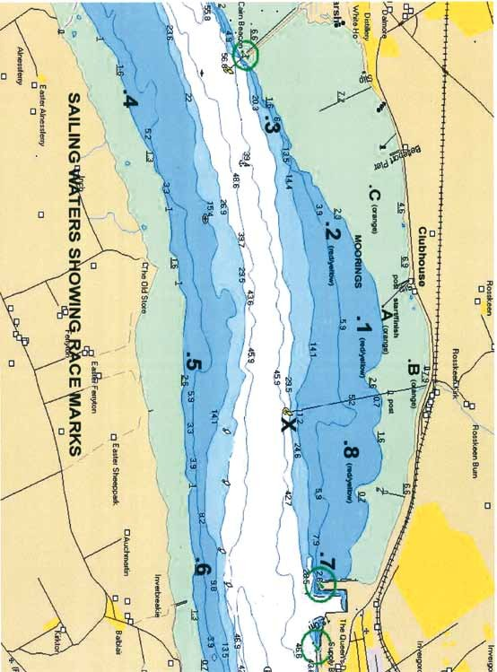
Y

